12.72: a) The radii 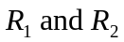 are measured with respect to the center of mass, and so
b) If the periods were different, the stars would move around the circle with respect to one another, and their separations would not be constant; the orbits would not remain circular. Employing qualitative physical principles, the forces on each star are equal in magnitude, and in terms of the periods, the product of the mass and the radial accelerations are
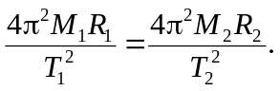

From the result of part (a), the numerators of these expressions are equal, and so the denominators are equal, and the periods are the same. To find the period in the symmetric from desired, there are many possible routes. An elegant method, using a bit of hindsight, is to use the above expressions to relate the periods to the force 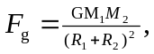so that equivalent expressions for the period are

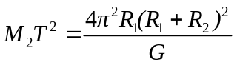

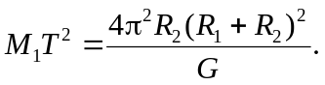

Adding the expressions gives

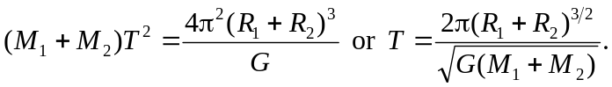

c) First we must find the radii of each orbit given the speed and period data. In a circular orbit, 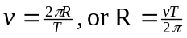 Thus
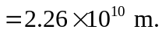Now find the sum of the masses and use 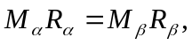and the fact that 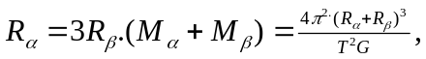 inserting the values of T, and the radii, Since d) Let black hole. Use the relationships derived in parts (a) and (b):
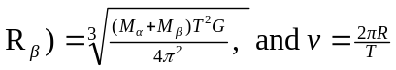. For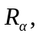 inserting the values for M and T and
Thus, for V616 Monocerotis, 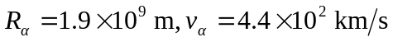and for the black hole: 